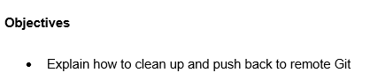

To clean up and push back to the remote Git repository, first we remove any unnecessary or temporary files from the local repository. Then we ensure that all changes are properly staged using git add and committed using git commit. After confirming a clean working state, we use git push to transfer the committed changes to the remote repository.

This maintains synchronization between local and remote repositories. It also ensures that only relevant and finalized changes are shared with collaborators.

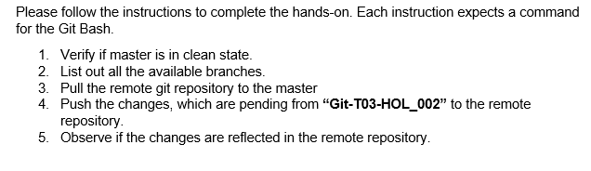

**Solution**

**Step 1**

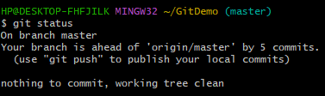

**Step 2**

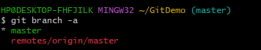

**Step 3**

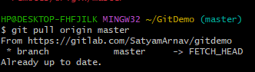

**Step 4**

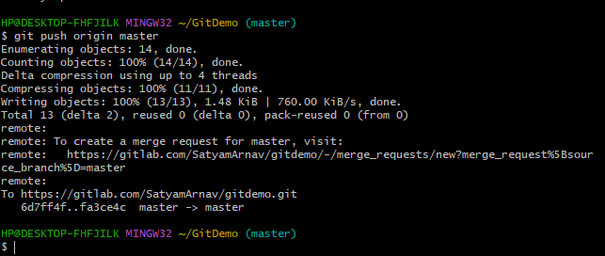

**Step 5**

